Lab - Create User Accounts in Windows 10

Introduction
In this lab, you will create user accounts in Windows 10.

Recommended Equipment
The following equipment is required for this exercise:
- A computer with a new installation of Windows 10
- Windows 10
  - Open the User Account Tool
    - Click Start menu button on lower left screen and key in control panel.
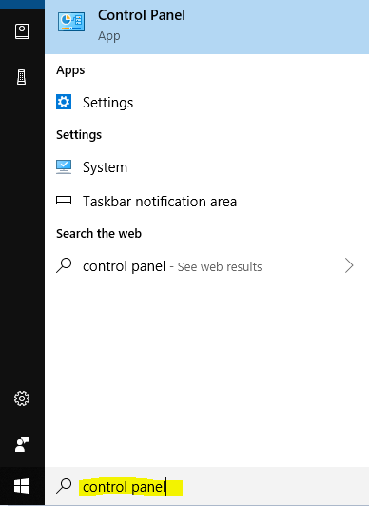
    - From Control Panel > User Accounts.
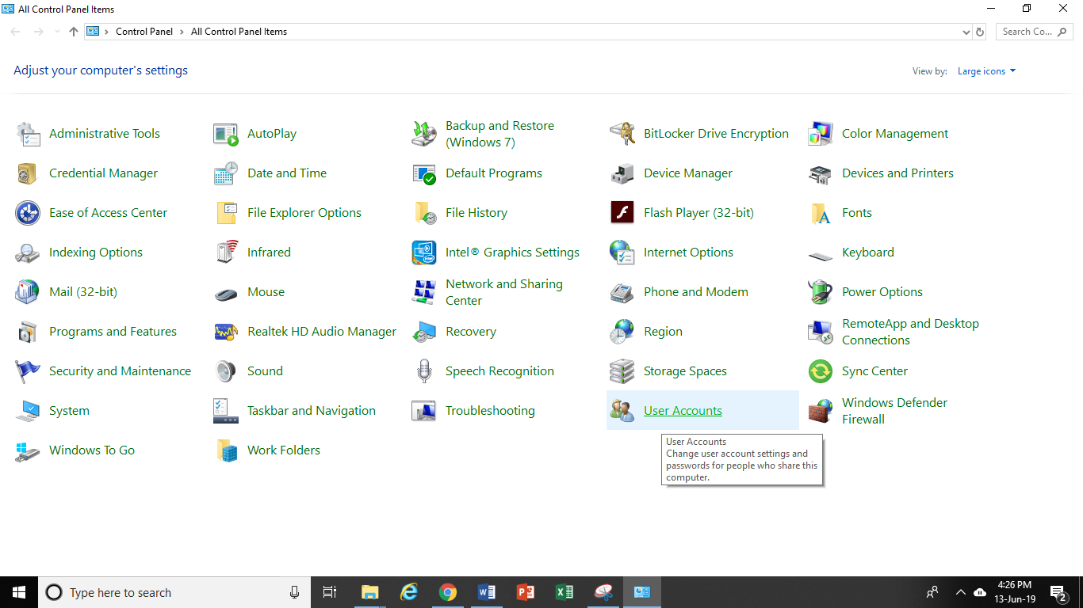

  - Create an Account
    - The User Accounts window opens. Click Manage another account.
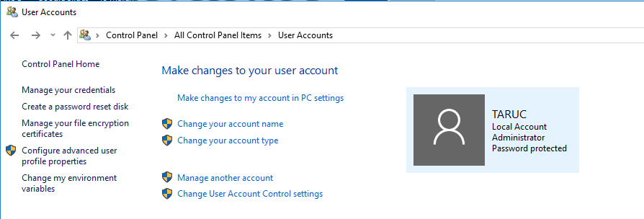

    - The Manage Accounts window opens. Click Add a new user in PC settings.
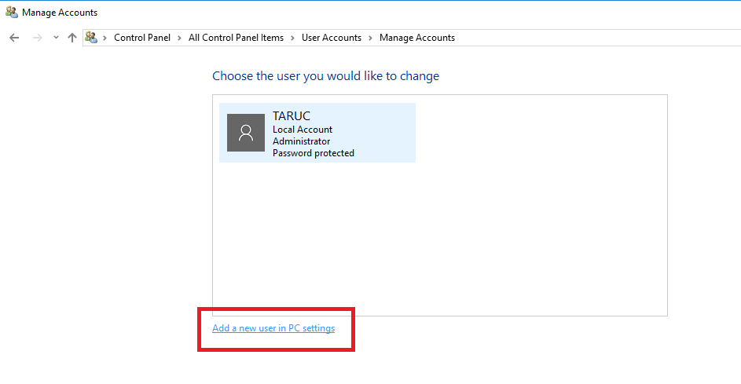

    - The Manage other accounts window opens. Click Add someone else to this PC.
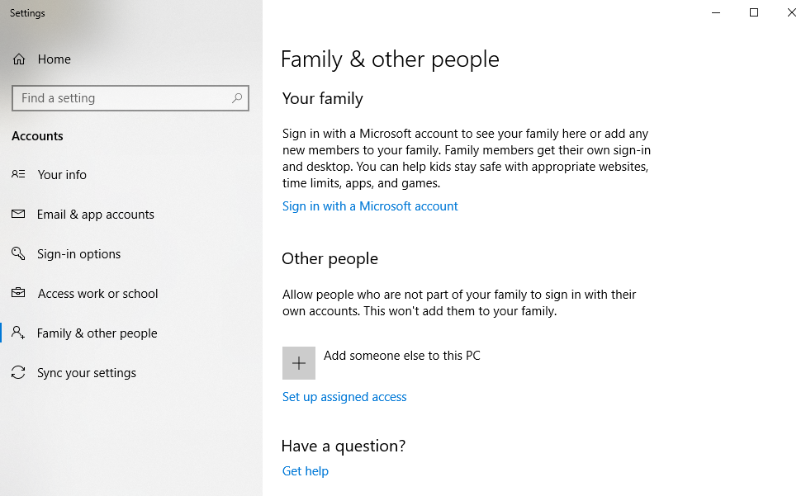

    - The How will this person sign in? window opens. Click I don’t have this person sign-in information.
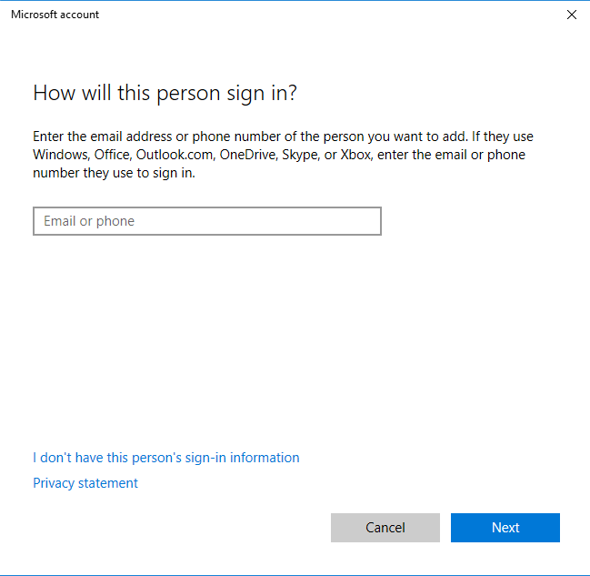

    - Click Add a user without a Microsoft Account.

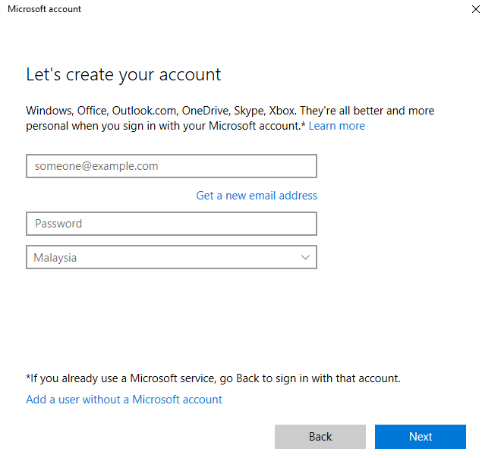
    - Type the name provided by your instructor (eg: Jessie) in the User name field.
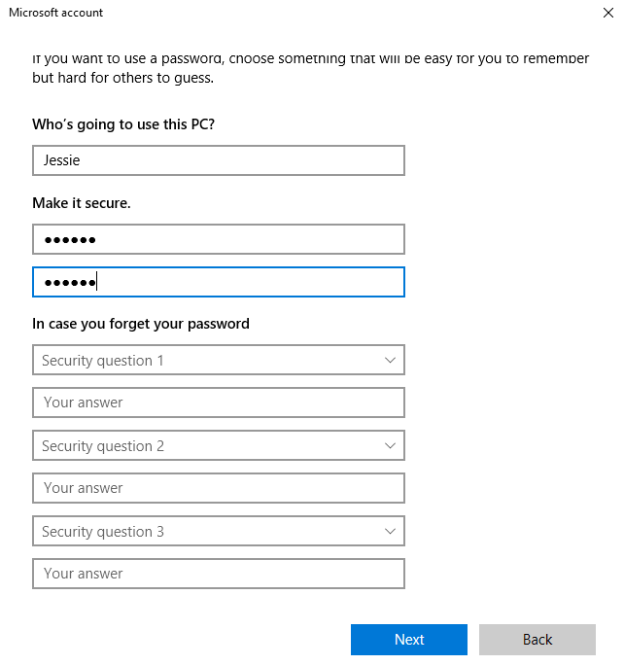
    - Type in the password provided by the instructor in the Password field.
    - Reenter the password in the Reenter password field.
    - Enter security questions in the “In case you forget your password”.
    - Click Next.
    - Local Account (eg: Jessie) will be created.
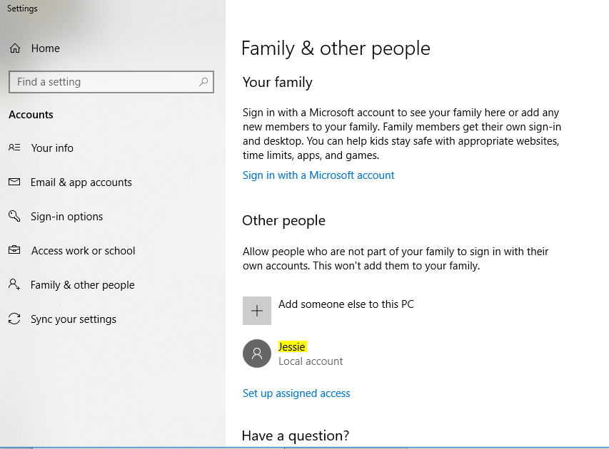
  - Change the Account Type
    - At the Settings window, click on the user you just created, and then click Change account type.
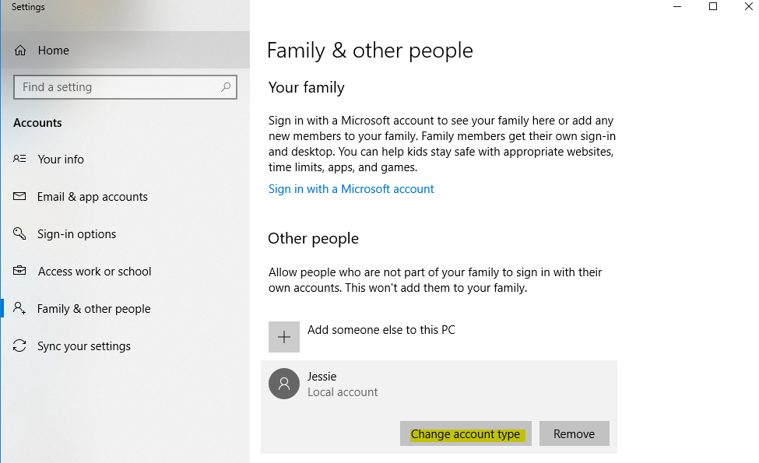
    - The Change account type window opens. Select Administrator as the account type. Click OK.
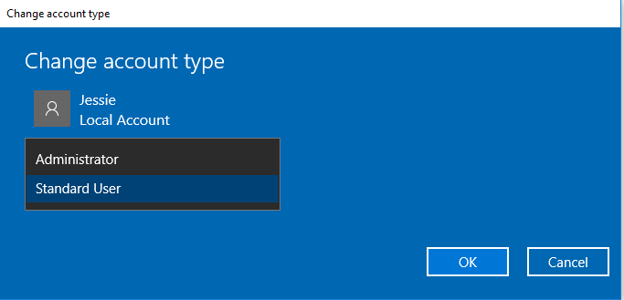
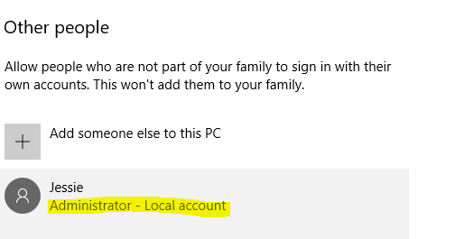
  - Delete the Account
    - In the Settings window, Click Remove.
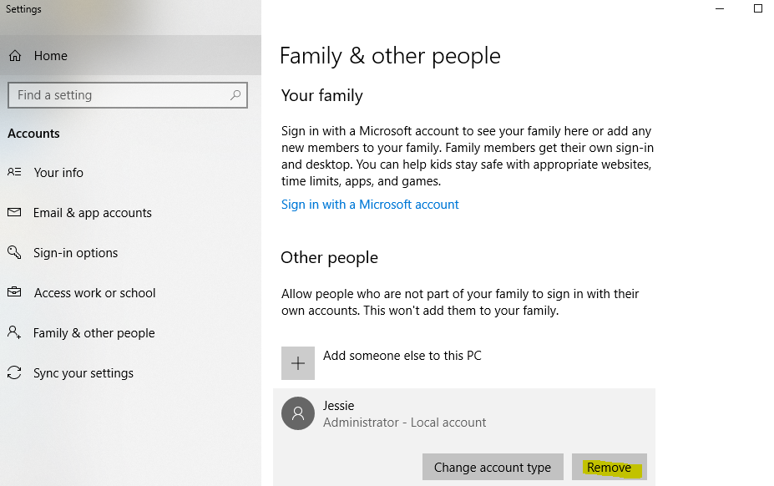

    - The Delete account and data? window opens. Click Delete account and data.
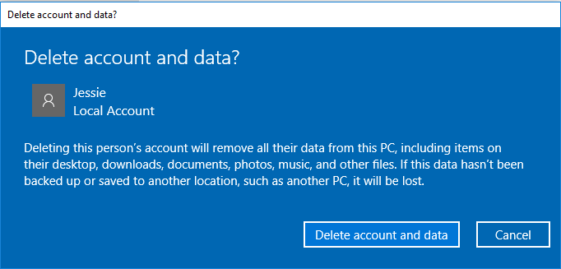
    - Notice the account (eg: Jessie) is no longer listed. Close all open windows.
